**PROJECT REPORT**

**PROJECT TITLE:**

DECIMAL TO BINARY CONVERTER

**COURSE NAME:**

COMPUTER ORGANIZATION & ASSEMBLY LANGUAGE

**SUBMITTED BY:**

FARHAN AFZAL CSC-18F-088

**SUBMITTED TO:**

Ma’am SAHAR ZAFAR

**SOURCE CODE:**

.model small

.stack 100h

.data

deci db 'Enter a decimal number : $'

invi db 'Invalid entry $'

bina db 'Its binary is $'

.code

main proc

mov ax,@data

mov ds,ax

mov ah,02

mov dl,10 ;print new line

int 21h

lea dx,deci

mov ah,9 ;print message

int 21h

mov ah,1

int 21h ;read data from user

cmp al,30h ;check whether user enter number or something else

jnge invalid ;jump if any invalid entry

cmp al,39h

jnle invalid

lea dx,bina ;print message

mov ah,9

int 21h

and al,0fh ;clear upper four bits of al register

mov cl,3 ;cl used as counter in shifting bits

mov bl,al ;save value in bl register

mov bh,bl ;move contents of bl into bh

shr bh,cl ;right shift bh register three times by using cl as a counter

add bh,30h ;make binary value visible as 0 or 1

mov ah,2 ;print binary value

mov dl,bh

int 21h

xor bh,bh ;clear bh register

mov bh,bl

mov cl,2 ;make cl counter value equals to two

and bh,04h ;clear all bits except third last bit

shr bh,cl

add bh,30h

mov ah,2 ;print binary value of third last bit

mov dl,bh

int 21h

xor bh,bh

mov bh,bl

and bh,02h ;clear all bits except second last bit

shr bh,1

add bh,30h

mov ah,2 ;print second last bit

mov dl,bh

int 21h

xor bh,bh

mov bh,bl

and bh,01h ;clear all bits except the last bit

add bh,30h

mov ah,2 ;print last bit in binary

mov dl,bh

int 21h

mov ah,02

mov dl,10 ;print new line

int 21h

jmp exit

invalid:

lea dx,invi ;used to print message of invalid entry

mov ah,9

int 21h

exit:

mov ah,4ch

int 21h

main endp

end main

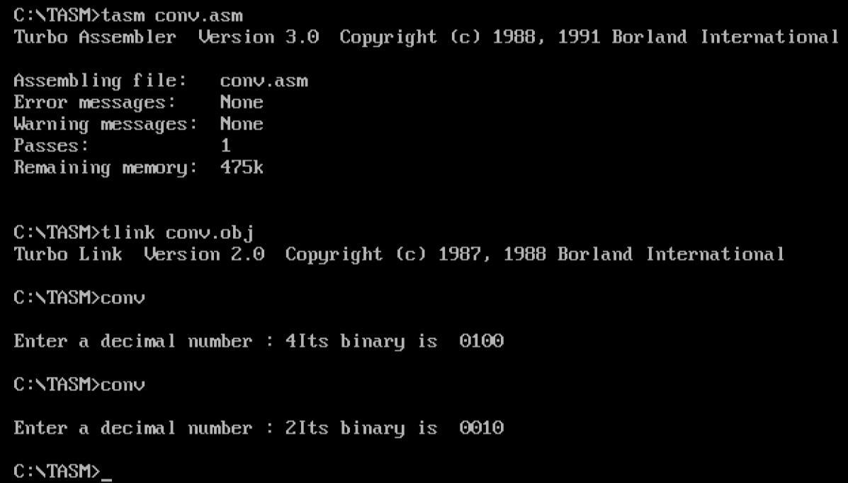**OUTPUT:**